AMERICAN INTERNATIONAL UNIVERSITY–BANGLADESH (AIUB)
FACULTY OF SCIENCE & TECHNOLOGY


Introduction to Database
Fall 2023-2024
Section: F, Group: 01

Project Title
Tourism Management System

Supervised By
Razuan Karim
Submitted By:
Name | ID | Contribution
1.MD.Wahiduzzaman Khan Dip | 22-48505-3
2.MD.Khalid Hasan | 22-48930-3
3.MD. AL Faysal | 22-48345-3
4.Estiak Rahman Ayon | 22-49753-3

INTRODUCTION
Organizing travel plans has grown more difficult in the fast-paced world of today. Our project is based on a tourism management system that aims to establish a comprehensive and efficient solution for managing travel arrangements. This project aims to simplify the process of storing and retrieving important travel-related data, including reservations for flights, hotel booking, meals, and other accommodations, by building a centralized database. By successfully implementing this project, the travel industry can benefit from improved efficiency and seamless travel experience for both travel agencies and individual users.

CASE STUDY
In a tourism management system, a travel agency employs several employees to handle various tasks. Various types of employees work for a travel agency. A travel agency usually contains an agency ID, name, address, phone number, and email address. On the other hand, an employee has an employee ID, name, date of birth, job type, salary, and different skills. Customers can approach a travel agency. A travel agency services many customers. A customer registers with a customer ID, name, address, phone number, email, and membership level. All kinds of addresses are composed of city, country, and zip code. A customer makes payments for various facilities. A payment process may include Pay ID, amount, date, etc. A customer takes flights for traveling. A flight includes flight number, airline, departure and arrival which is composed by country and time. A customer uses various types of local transportation. Local transportation generally has a transport number, booking date, pick-up location, drop-in location, and mode of transport. Customers make reservations at hotels. On the other hand, A hotel offers accommodations to the customers and the customer gets accommodations. To make accommodations, there is an accommodation ID, in date, out date, room type and room number. A hotel manages food booking. Different types of food bookings are offered by a hotel. Food booking is maintained by booking ID, booking date, meal type, and total number of guests. In total, there are 9 entities in the project.

ER DIAGRAM

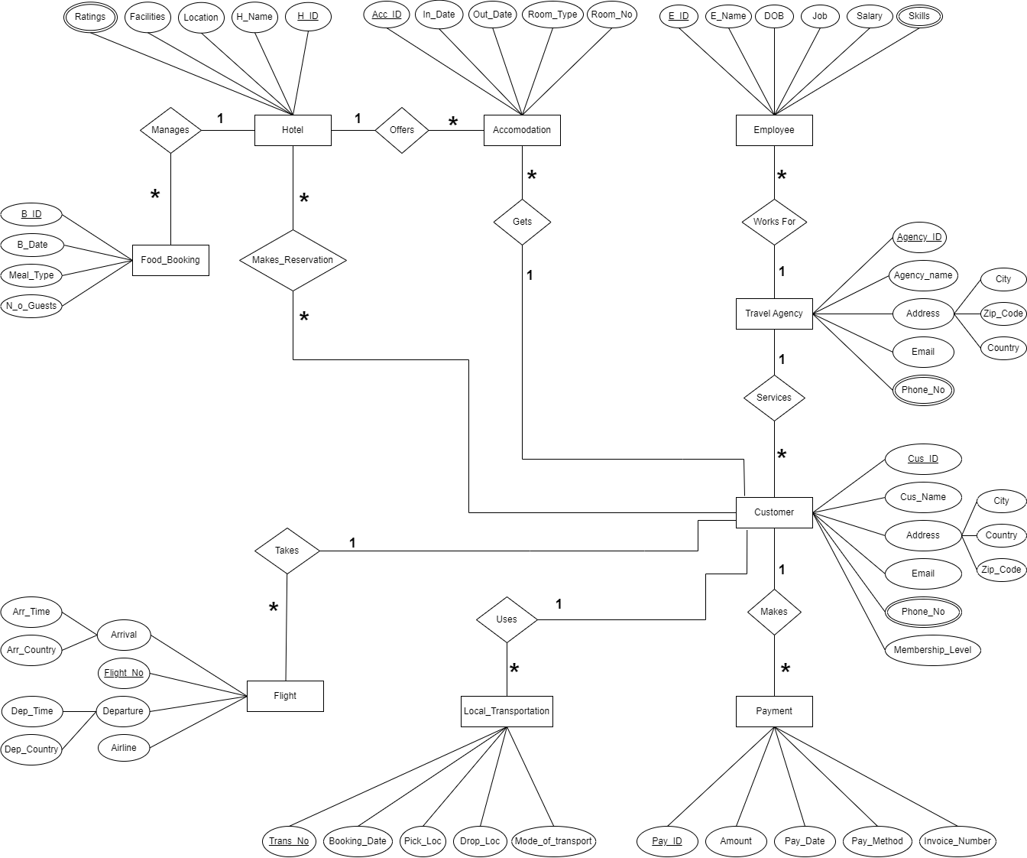

Fig-1: ER-Diagram for Tourism Management System

GANTT CHART:

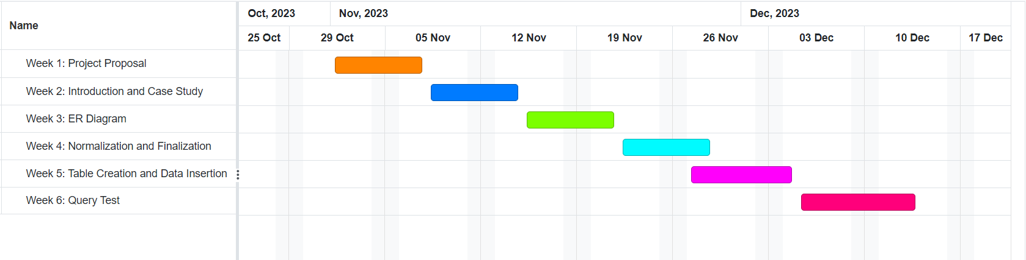

NORMALIZATION:

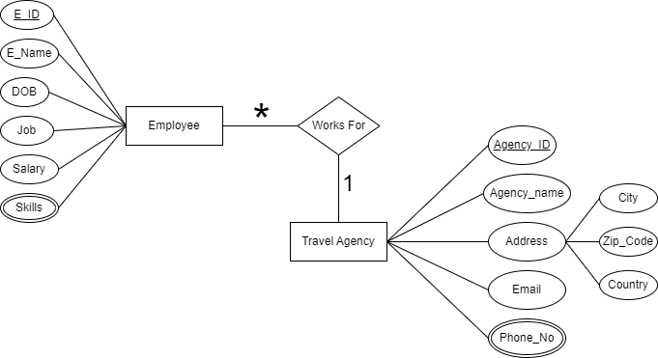

Fig-2: ER-Diagram for Employee – works for – Travel Agency

Relation: Many to One
UNF: Agency ID, Agency_Name, City, Country, Zip_code, Phone_No, Email, E_ID, E_Name, DOB, Job Title, Salary, Skills
1NF: Multivalued attributes: Phone_No, Skills.
Agency ID, Agency_Name, City, Country, Zip_code, Email, E_ID, E_Name, Date of Birth, Job Title, Salary

2NF: 1. Agency ID, Phone_No
- E_ID, Skills
- Agency ID, Agency_Name, City, Country, Zip_code, Email
- E_ID, E_Name, DOB, Job Title, Salary, Agency ID

3NF: 1. Agency ID, City, Country, Zip_code
- Agency ID, Phone_No
- E_ID, Skills
- Agency ID, Agency_Name, Email
- E_ID, E_Name, DOB, Job Title, Salary, Agency ID
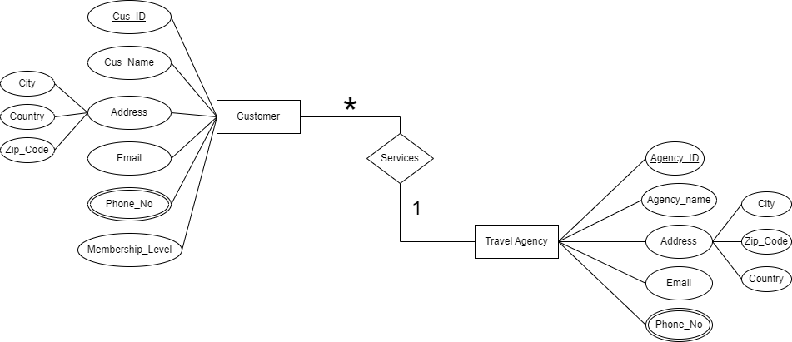
Fig-3: ER-Diagram for Travel Agency – services – Customer

Relation: One to Many
UNF: Agency ID, Agency_Name, City, Country, Zip_code, Phone_No, Email, Cus_ID, Cus_Name, City, Country, Zip_code, Email, Phone_No, Membership_Level
1NF: Multivalued attributes: Phone_No, Phone_No.
Agency ID, Agency_Name, City, Country, Zip_code, Email, Cus_ID, Cus_Name, City, Country, Zip_code, Email, Membership_Level
2NF: 1. Agency ID, Phone_No
  - Cus_ID, Phone_No
  - Agency ID, Agency_Name, City, Country, Zip_code, Email
  - Cus_ID, Cus_Name, City, Country, Zip_code, Email, Membership_Level, Agency ID

3NF: 1. Agency ID, City, Country, Zip_code
- Cus_ID, City, Country, Zip_code
- Agency ID, Phone_No
- Cus_ID, Phone_No
- Agency ID, Agency_Name, Email
- Cus_ID, Cus_Name, Email, Membership_Level, Agency ID
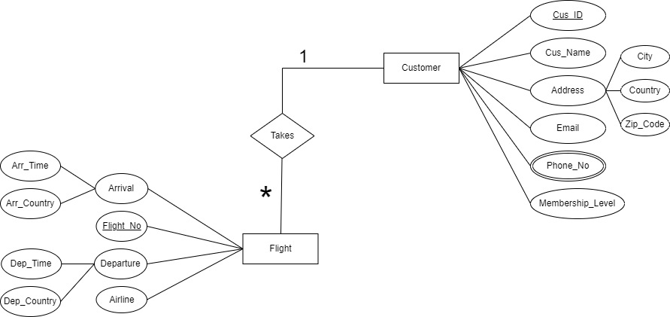

Fig-4: ER-Diagram for Customer – takes – Flight

Relation: One to Many

UNF: Cus_ID, Cus_Name, City, Country, Zip_code, Email, phone_no, Membership_Level, Flight_No, Airline, Dep_Country, Arr_Country, Dep_Time, Arr_Time
1NF: Multivalued attributes: Phone_No
Cus_ID, Cus_Name, City, Country, Zip_code, Email, Membership_Level, Flight_No, Airline, Dep_Country, Arr_Country, Dep_Time, Arr_Time

2NF: 1. Cus_ID, Phone_No
2.Flight_No, Airline, Dep_Country, Arr_Country, Dep_Time, Arr_Time, Cus_ID
3.Cus_ID, Cus_Name, City, Country, Zip_code, Email, Membership_Level

3NF: 1. Cus_ID, Phone_No
- Flight_No, Dep_Country, Arr_Country, Dep_Time, Arr_Time
- Cus_ID, City, Country, Zip_code
- Cus_ID, Cus_Name, Email, Membership_Level
- Flight_No, Airline, Cus_ID

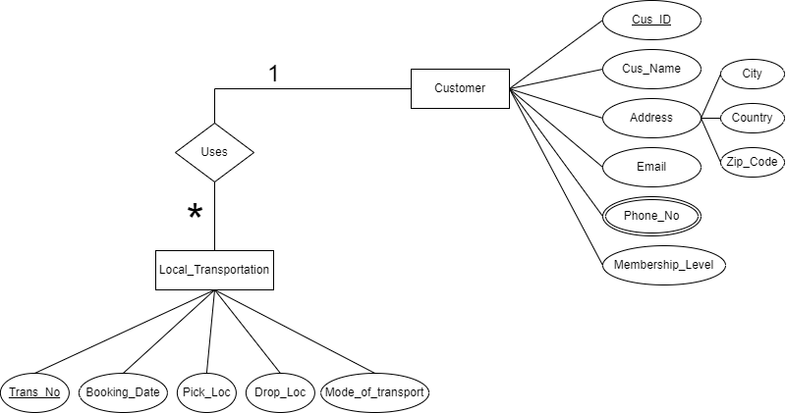

Fig-5: ER-Diagram for Customer – uses – Local_Transportation

Relation: One to Many
UNF: Cus_ID, Cus_Name, City, Country, Zip_code, Email, Phone_No, Membership_Level, Trans_No, Booking_Date, Pick_Loc, Drop_Loc, Mode_of_Transport

1NF: Multivalued attributes: Phone_No
Cus_ID, Cus_Name, City, Country, Zip_code, Email, Membership_Level, Trans_No, Booking_Date, Pick_Loc, Drop_Loc, Mode_of_Transport

2NF: 1. Cus_ID, Phone_No
2.Trans_No, Booking_Date, Pick_Loc, Drop_Loc, Mode_of_Transport,

Cus_ID
3.Cus_ID, Cus_Name, City, Country, Zip_code, Email, Membership_Level
3NF: 1. Cus_ID, City, Country, Zip_code
- Cus_ID, Phone_No
- Trans_No, Booking_Date, Pick_Loc, Drop_Loc, Mode of Transport,

Cus_ID
- Cus_ID, Cus_Name, Email, Membership_Level

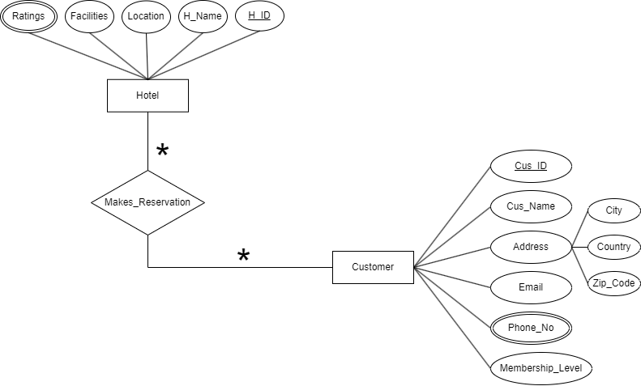

Fig-6: ER-Diagram for Customer – makes_reservation – Hotel

Relation: Many to Many

UNF: Cus_ID, Cus_Name, City, Country, Zip_code, Email, Phone_No, Membership_Level, H_ID, H_Name, Location, Facilites, Ratings
1NF: Multivalued attributes: Phone_No, Ratings
Cus_ID, Cus_Name, City, Country, Zip_code, Email, Phone_No, Membership_Level, H_ID, H_Name, Location, Facilites

2NF: 1. Cus_ID, Phone_No
2.H_ID, Ratings
3.Cus_ID, Cus_Name, City, Country, Zip_code, Email, Membership_Level
4.H_ID, H_Name, Location, Facilities, Cus_ID
3NF: 1. Cus_ID, City, Country, Zip_code
- Cus_ID, Phone_No
- H_ID, Ratings
- Cus_ID, Cus_Name, Email, Membership_Level
- H_ID, H_Name, Location, Facilities, Cus_ID

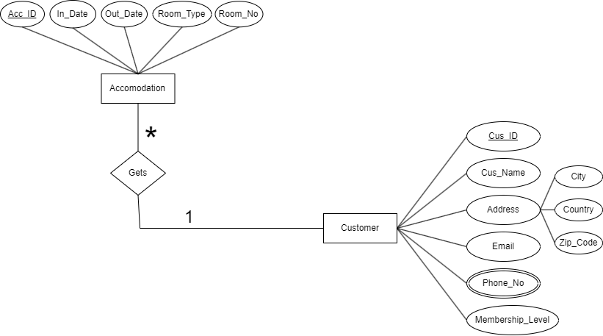

Fig-7: ER-Diagram for Customer – gets – Accommodation

Relation: One to Many

UNF: Cus_ID, Cus_Name, City, Country, Zip_code, Email, phone_no, Membership_Level, Acc_ID, In_Date, Out_Date, Room_Type, Room_No

1NF: Multivalued attributes: Phone_No
Cus_ID, Cus_Name, City, Country, Zip_code, Email, Membership_Level, Acc_ID, In_Date, Out_Date, Room_Type, Room_No

2NF: 1. Cus_ID, Phone_No
2.Acc_ID, In_Date, Out_Date, Room_Type, Room_No, Cus_ID
3.Cus_ID, Cus_Name, City, Country, Zip_code, Email, Membership_Level

3NF: 1. Cus_ID, City, Country, Zip_code
- Cus_ID, Phone_No
- Cus_ID, Cus_Name, Email, Membership_Level
- Acc_ID, In_Date, Out_Date, Room_Type, Room_No, Cus_ID

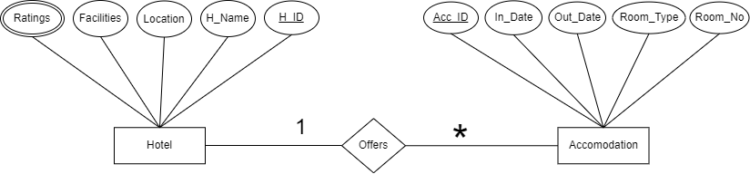

Fig-8: ER-Diagram for Hotel – offers – Accommodation

Relation: One to Many
UNF: Acc_ID, In_Date, Out_Date, Room_Type, Room_No, H_ID, H_name, location, Facilities, Ratings
1NF: Multivalued attributes: Ratings
Acc_ID, In_Date, Out_Date, Room_Type, Room_No, H_ID, H_name, location, Facilites

2NF: 1. H_ID, Ratings
2.Acc_ID, In_Date, Out_Date, Room_Type, Room_No, H_ID
3.H_ID, H_name, location, Facilites
3NF: 1. H_ID, Ratings
- Acc_ID, In_Date, Out_Date, Room_Type, Room_No, H_ID
- H_ID, H_name, location, Facilites

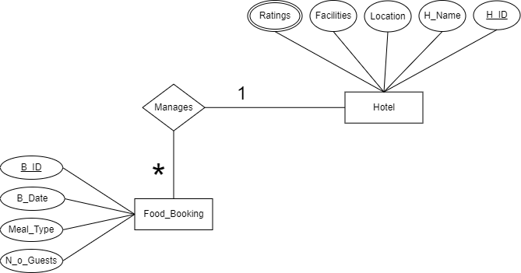

Fig-9: ER-Diagram for Hotel – manages – Food_Booking

Relation: One to Many

UNF: H_ID, H_name, location, Facilities, Ratings, B_ID, B_Date, Meal_Type, N_o_Guests
1NF: Multivalued attributes: Ratings
H_ID, H_name, location, Facilities, B_ID, B_Date, Meal_Type, N_o_Guests

2NF: 1. H_ID, Ratings
2.H_ID, H_name, location, Facilities
3.B_ID, B_Date, Meal_Type, N_o_Guests, H_ID
3NF: 1. H_ID, Ratings
- H_ID, H_name, location, Facilities
- B_ID, B_Date, Meal_Type, N_o_Guests, H_ID

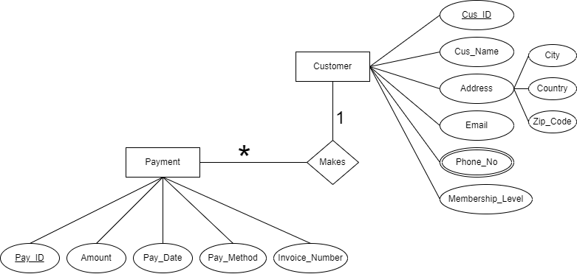

Fig-10: ER-Diagram for Customer – makes – Payment

Relation: One to Many
UNF: Cus_ID, Cus_Name, City, Country, Zip_code, Email, phone_no, Membership_Level, Pay_ID, Amount, Pay_Date, Pay_Method, Invoice_Number, Phone_No
1NF: Multivalued attributes: Phone_No
Cus_ID, Cus_Name, City, Country, Zip_code, Email, Membership_Level, Pay_ID, Amount, Pay_Date, Pay_Method, Invoice_Number_Phone_No

2NF: 1. Cus_ID, Phone_No
2.Cus_ID, Cus_Name, City, Country, Zip_code, Email, Membership_Level
3.Pay_ID, Amount, Pay_Date, Pay_Method, Invoice_Number, Cus_ID

3NF: 1. Cus_ID, City, Country, Zip_code
- Cus_ID, Phone_No
- Cus_ID, Cus_Name, Email, Membership_Level
- Pay_ID, Amount, Pay_Date, Pay_Method, Invoice_Number, Cus_ID

FINALIZATION:

- Agency ID, Phone_No
- Agency ID, City, Country, Zip_code
- Agency ID, Agency_Name, Zip_code, Email
- E_ID, E_Name, DOB, Job Title, Salary, Agency ID
- E_ID, Skills
- Agency ID, City, Country, Zip_code
- Agency ID, Agency_Name, Email
- Agency ID, Phone_No
- Cus_ID, Phone_No
- Cus_ID, City, Country, Zip_code
- Cus_ID, Cus_Name, Email, Membership_Level, Agency ID
- Cus_ID, City, Country, Zip_code
- Cus_ID, Phone_No
- Trans_No, Booking_Date, Pick_Loc,Drop_loc,Mode of Transport, Cus_ID
- Cus_ID, Cus_Name, Email, Membership_Level
- Cus_ID, City, Country, Zip_code
- Cus_ID, Phone_No
- H_ID, Ratings
- Cus_ID, Cus_Name, Email, Membership_Level
- H_ID, H_Name, Location, Facilities, Cus_ID
- Cus_ID, City, Country, Zip_code
- Cus_ID, phone_no
- Cus_ID, Cus_Name, Email, Membership_Level
- Pay_ID, Amount, Pay_Date, Pay_Method, Invoice_Number, Cus_ID
- Cus_ID, phone_no
- H_ID, H_name, location, Facilities
- B_ID, B_Date, Meal_Type, N_o_Guests, H_ID
- Cus_ID, City, Country, Zip_code
- Cus_ID, phone_no
- Cus_ID, Phone_No
- Acc_ID, In_Date, Out_Date, Room_Type, Room_No, Cus_ID
- H_ID, Ratings
- Acc_ID, In_Date, Out_Date, Room_Type, Room_No, H_ID
- H_ID, H_name, location, Facilities
- Cus_ID, Cus_Name, Email, Membership_Level
- Cus_ID, Email, Membership_Level
- Cus_ID, City, Country, Zip_code
- Flight_No, Dep_Country, Arr_Country, Dep_Time, Arr_Time
- Flight_No, Airline, Cus_ID

FINAL TABLE:

- (Agency_Loc) - Agency ID, City, Country, Zip_code
- (Agency_Con) - Agency ID, Phone_No

- (Agency_Info) - Agency ID, Agency_Name, Email

- (EMP_Skill) - E_ID, Skills
- (EMP_Info) - E_ID, E_Name, DOB, Job Title, Salary, Agency ID

- (CUS_Loc) - Cus_ID, City, Country, Zip_code
- (Cus_Con) - Cus_ID, Phone_No
- (CUS_Info) - Cus_ID, Cus_ID, Cus_Name, Email, Membership_Level, Agency ID

- (Airline_Info) - Flight_No, Dep_Country, Arr_Country, Dep_Time, Arr_Time
- (Airline) - Flight_No, Airline, Cus_ID
- (Transportation) - Trans_No, Booking_Date, Pick_Loc, Drop_Loc, Mode_of _Transport, Cus_ID
- (Hotel_Info) - H_ID, H_Name, Location, Facilities, Cus_ID
- (Hotel_Ratings) - H_ID, Ratings
- (Accommodation) - Acc_ID, In_Date, Out_Date, Room_Type, Room_No, Cus_ID, H_ID

- (Food_Booking) - B_ID, B_Date, Meal_Type, N_o_Guests, H_ID
- (Payment) - Pay_ID, Amount, Pay_Date,Pay_Method, Invoice_Number, Cus_ID

TABLE CREATION:
1. AGENCY_INFO:
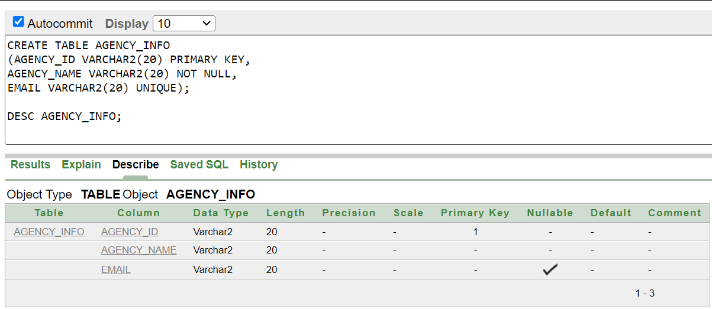

2. AGENCY_LOC:
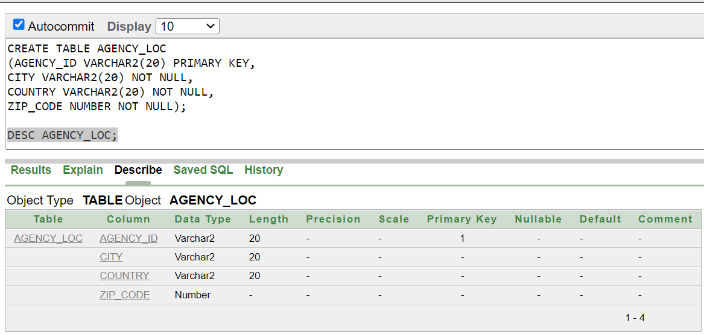

3. AGENCY_CON:
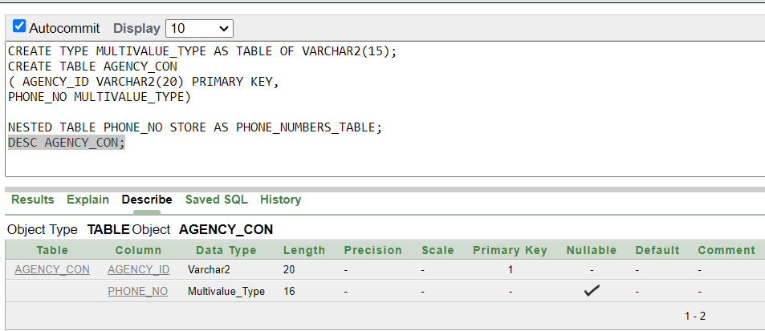

4. EMP_INFO:
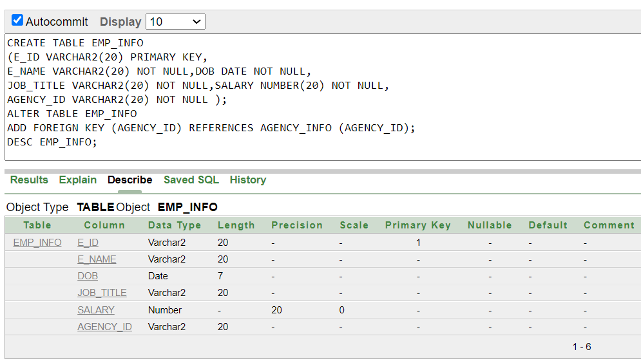

5. EMP_SKILL:
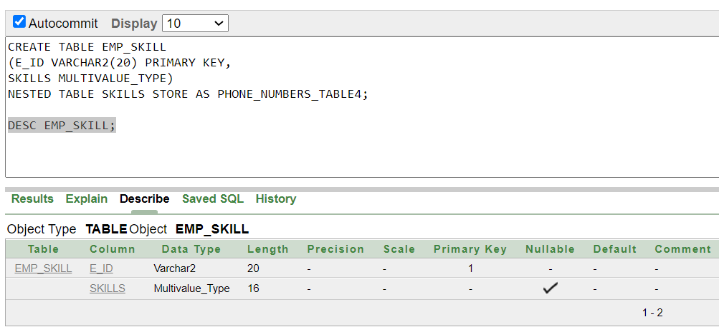

6. CUS_INFO:
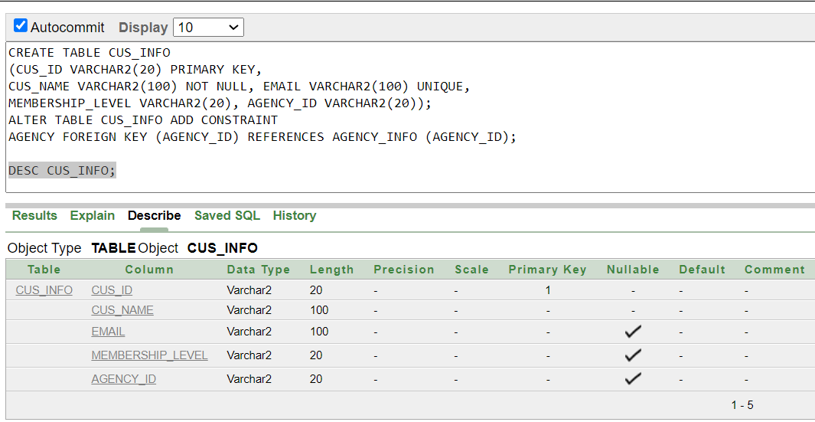

7. CUS_LOC:
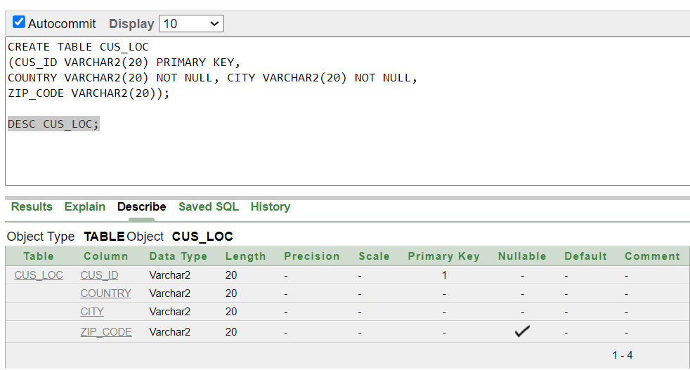

8.CUS_CON:
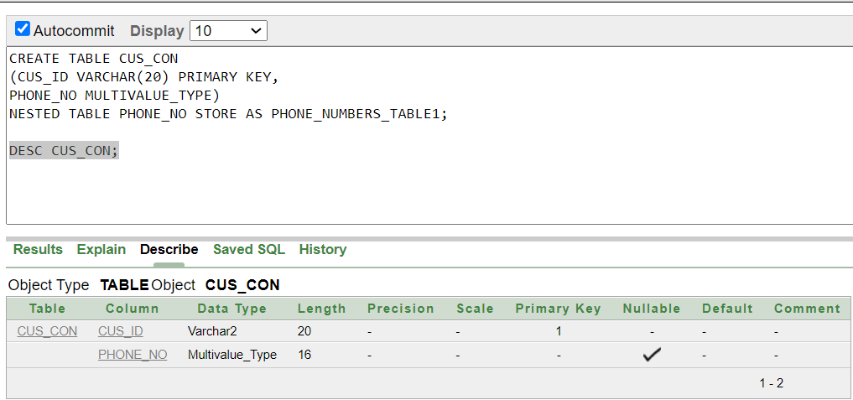

9.AIRLINE:
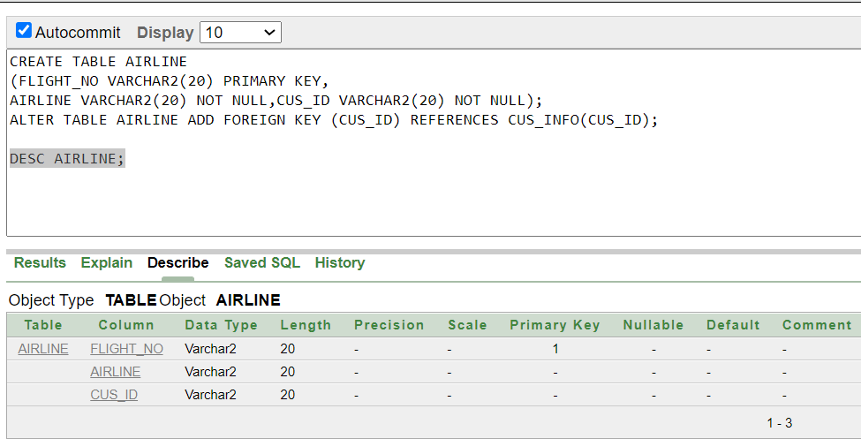

10. AIRLINE_INFO:
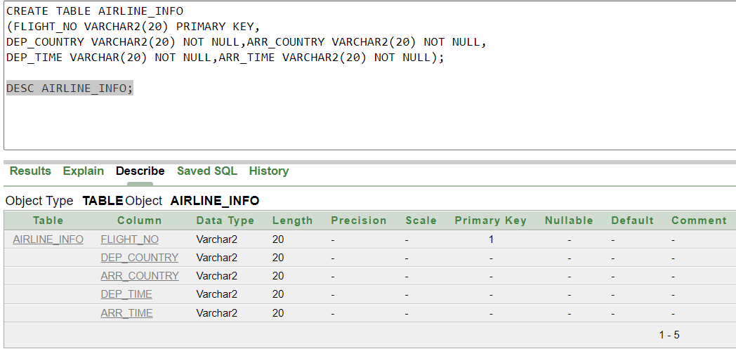

11. TRANSPORTATION:

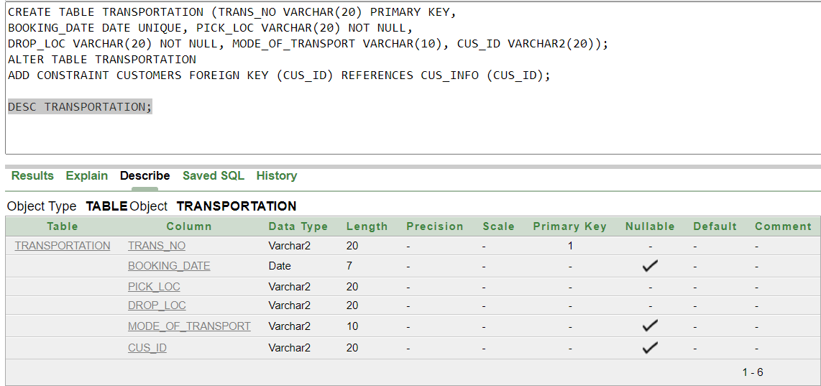

12.HOTEL_INFO:

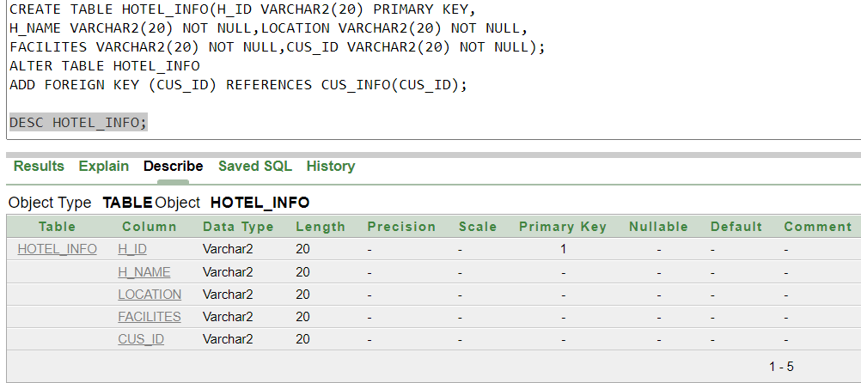

13.ACCOMODATION:

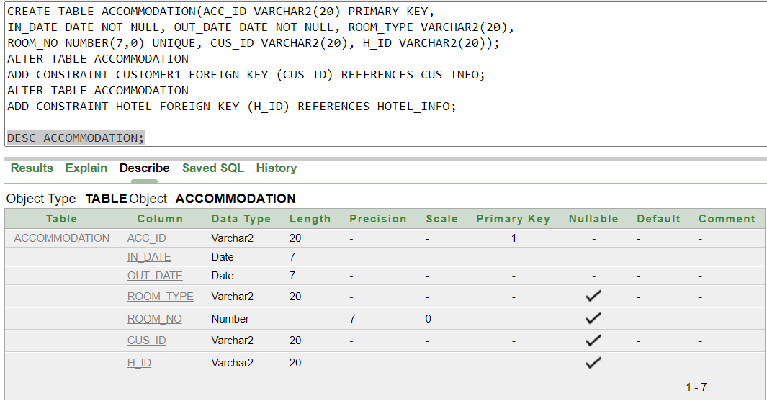

14. FOOD_BOOKING:

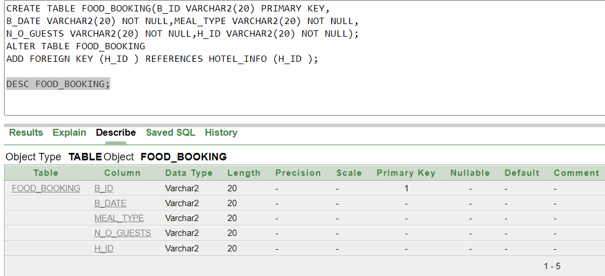

15. HOTEL_RATINGS:

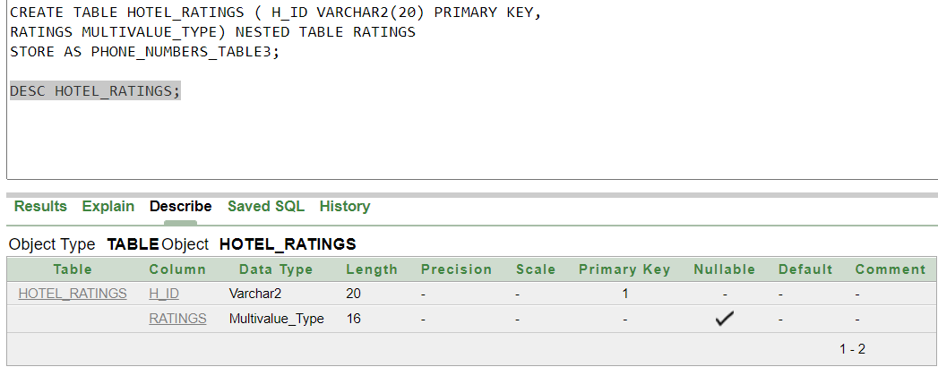

16.PAYMENT:

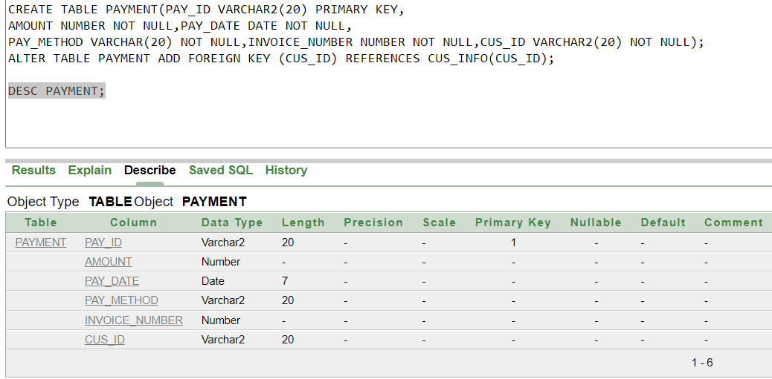

VALUE INSERTION:
1. AGENCY_INFO:
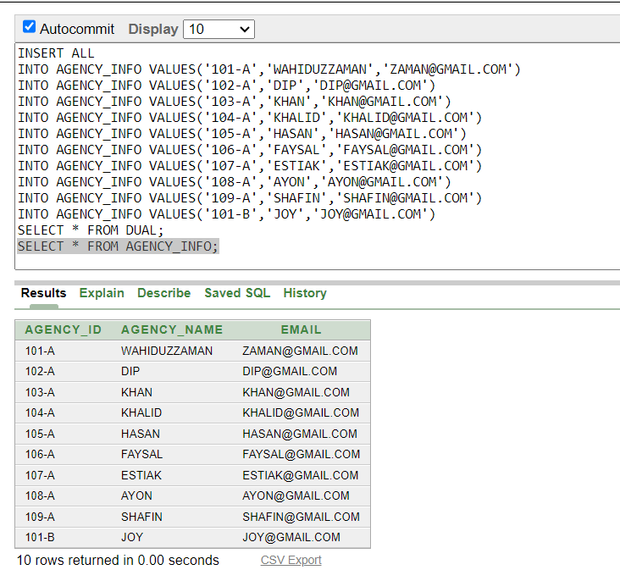

2. AGENCY_LOC:
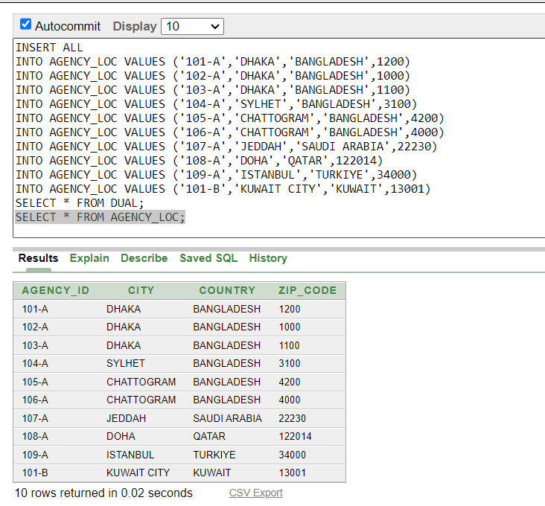

3. AGENCY_CON:
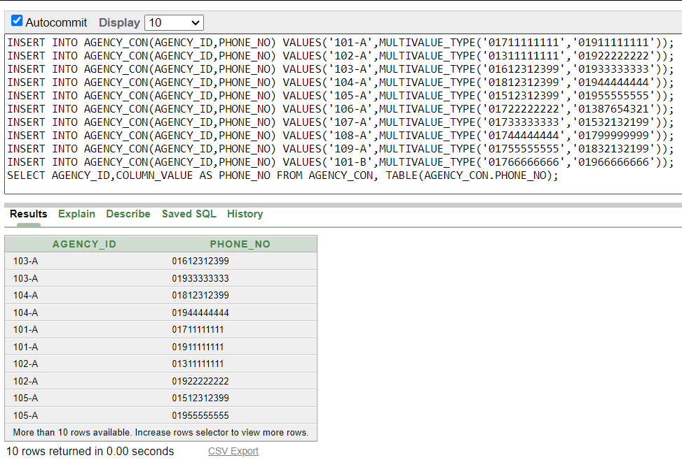

4. EMP_INFO:
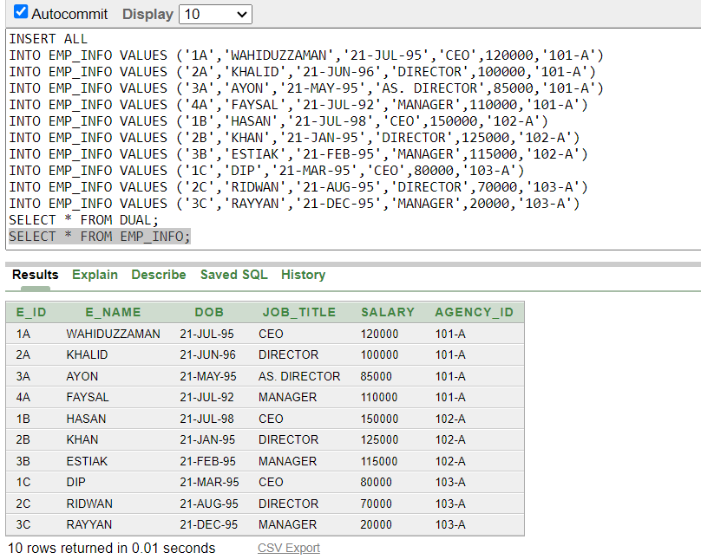

5. EMP_SKILL:
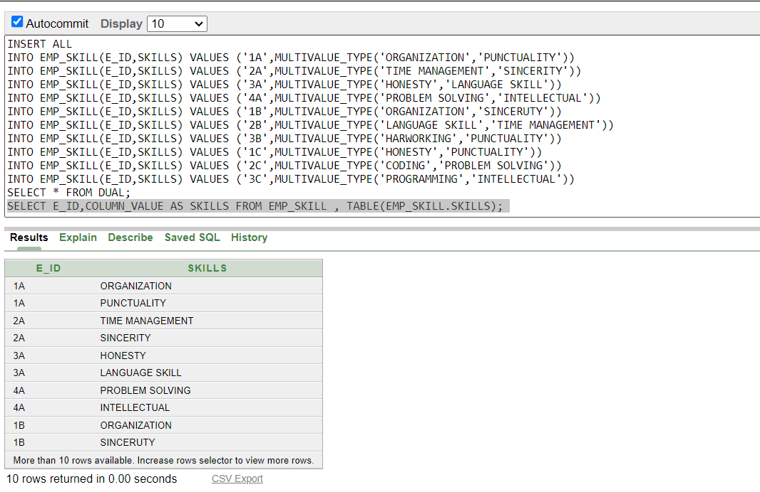

6. CUS_INFO:
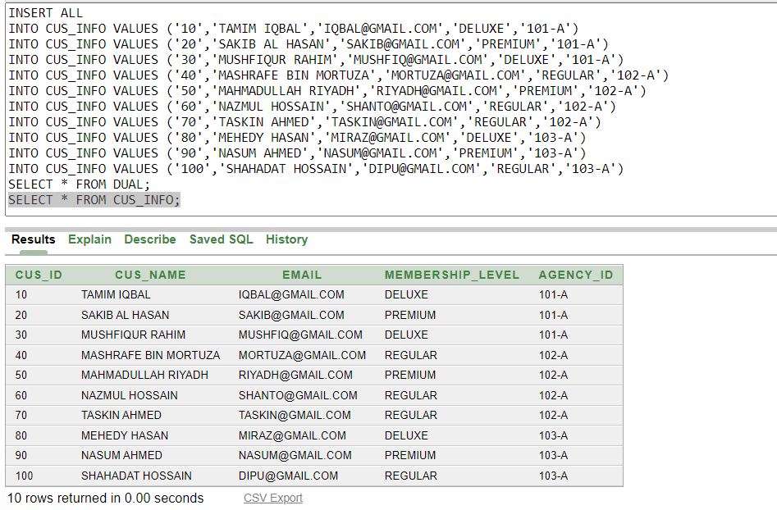
7. CUS_LOC:
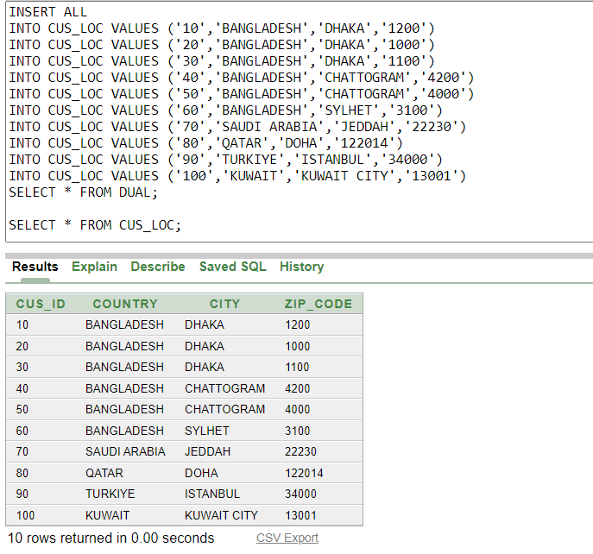

8.CUS_CON:
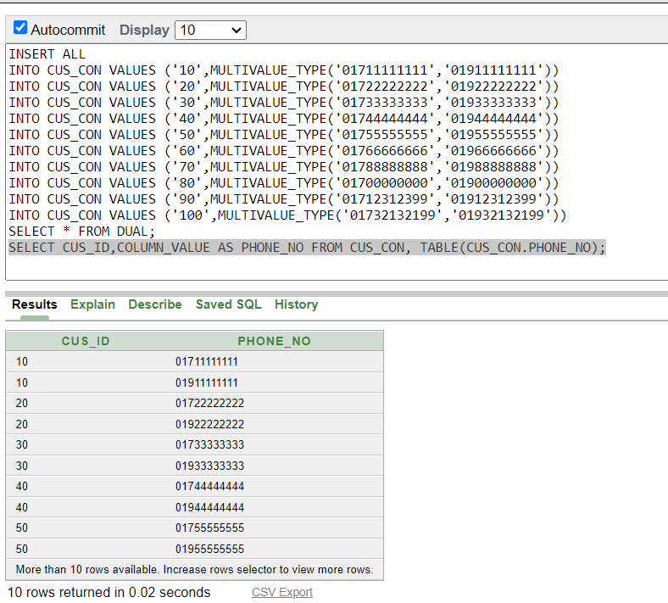
9.AIRLINE:
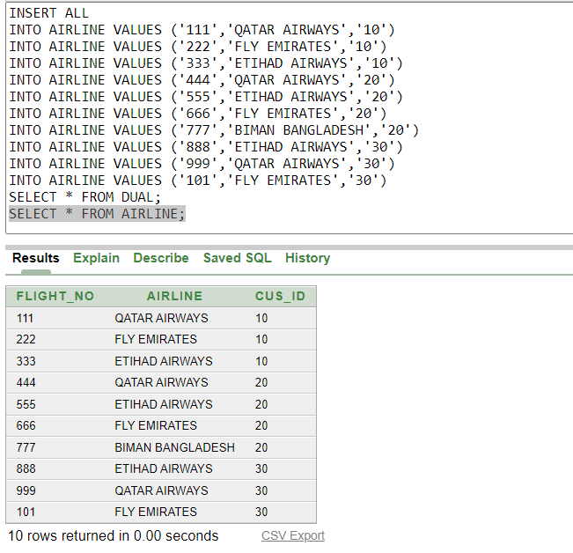

10. AIRLINE_INFO:
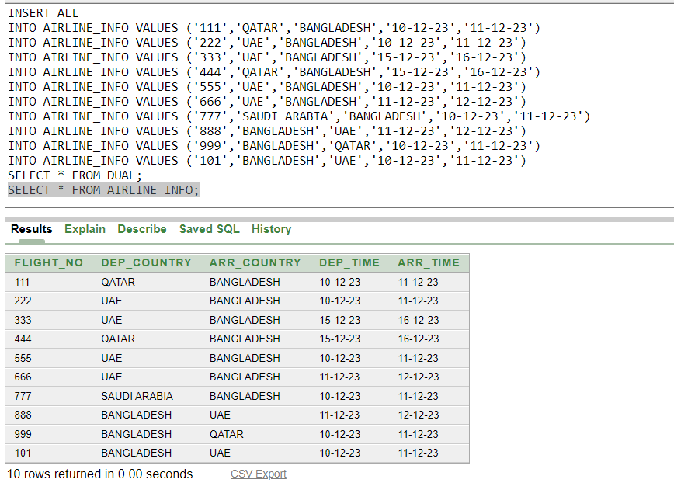

11. TRANSPORTATION:

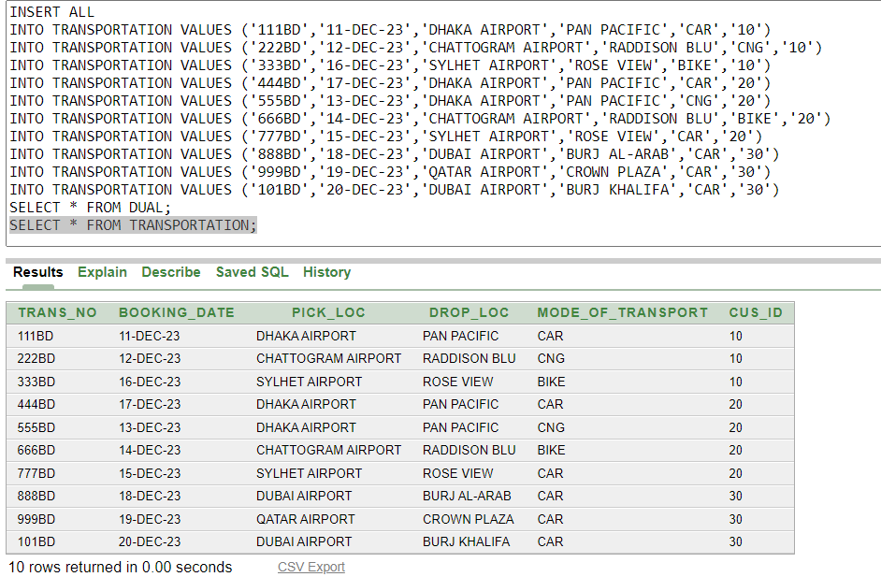

12.HOTEL_INFO:
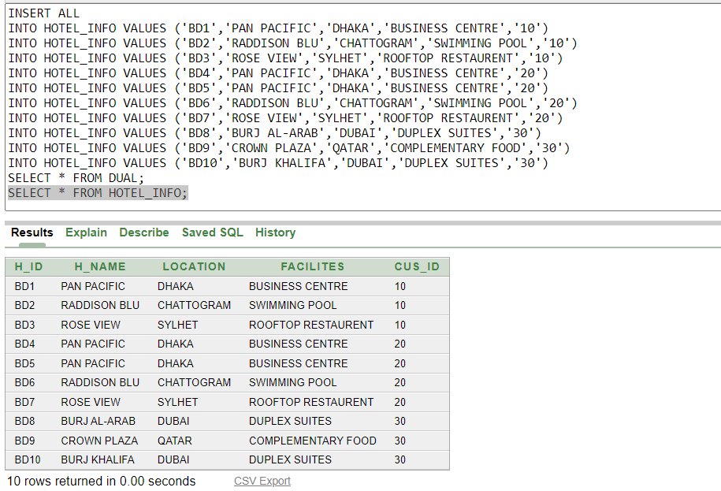
13.ACCOMODATION:
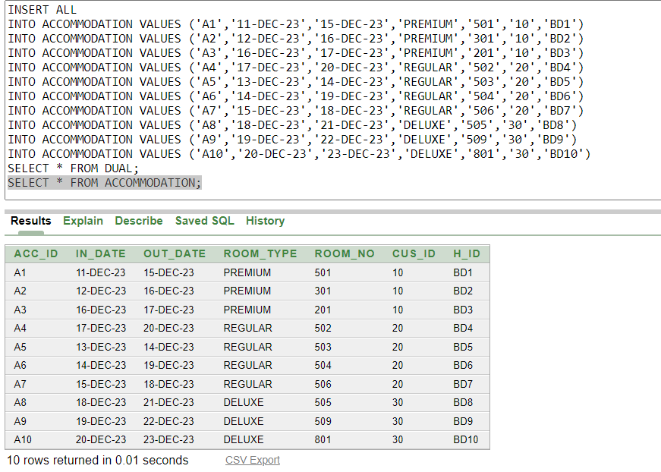
14. FOOD_BOOKING:
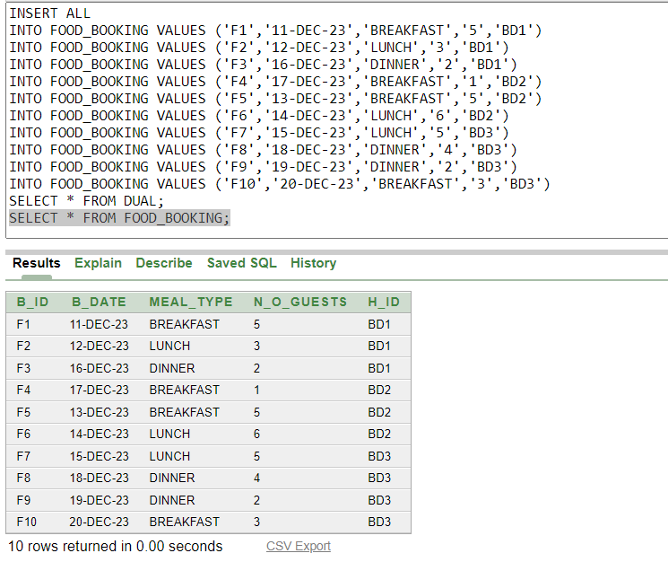
15. HOTEL_RATINGS:
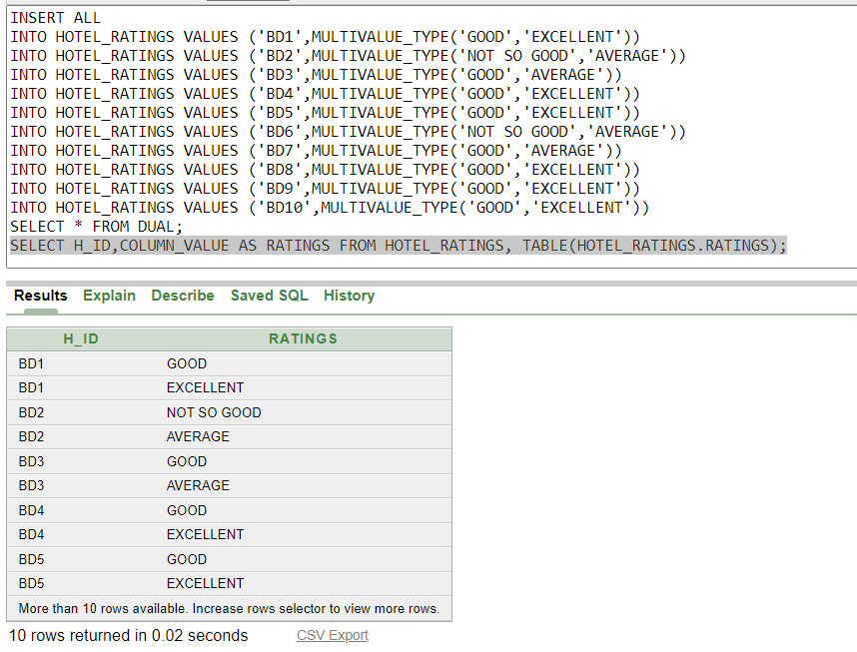

16.PAYMENT:
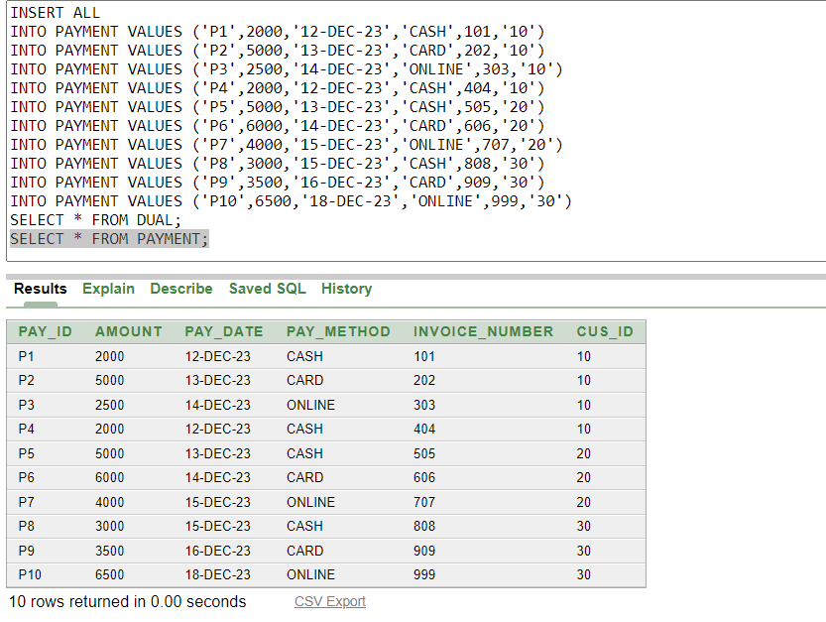
Query Testing:
Single Row Query:
01.Show all information of Agency which ID ends with ‘A’ .

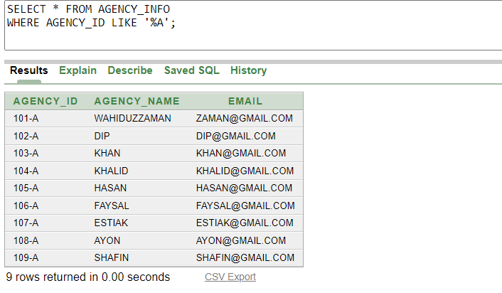

02.Show customer’s payment ranges from 3000 to 6000.

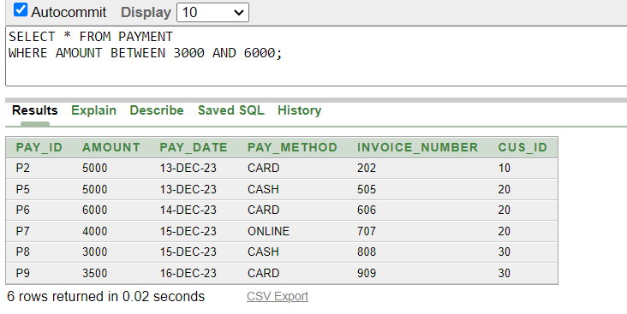

03.Show the list of customers who have Deluxe,Premium membership.

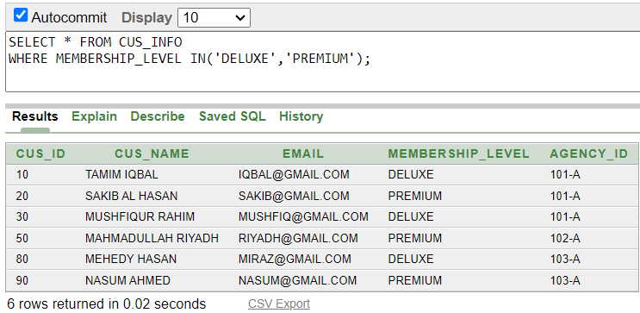

Multiple Row Query:
04.Show the salaries of CEOs who earn more than 120,000.

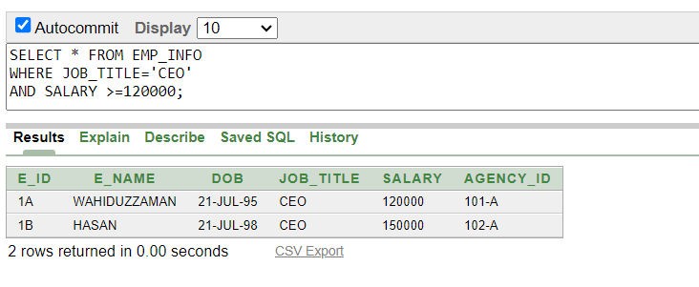

05.Show the information of employees who are CEO or earn more than 120,000.

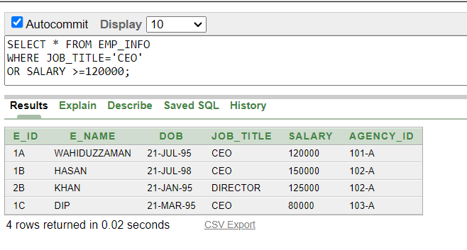

06.Show the information of the employees who are not CEO.Also create a temporary column and name it “Annual Salary” and arrange the table by descending order based on salary.

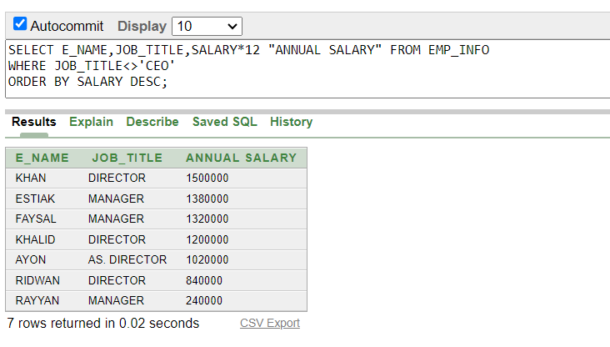
Sub-query(Single Row):
07.Show the customers information who owns same membership as of “TAMIM IQBAL”.

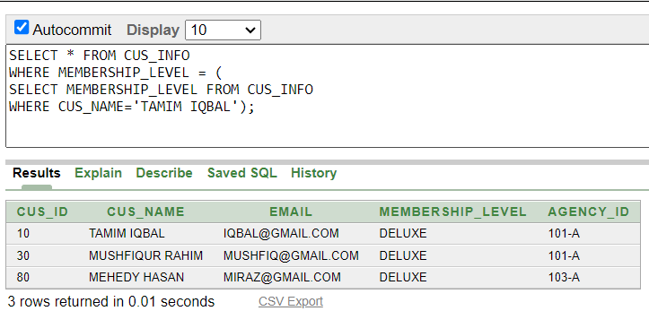

08.Show the information of employees who are at the same position as of “WAHIDUZZAMAN” and earns more than “KHALID”.

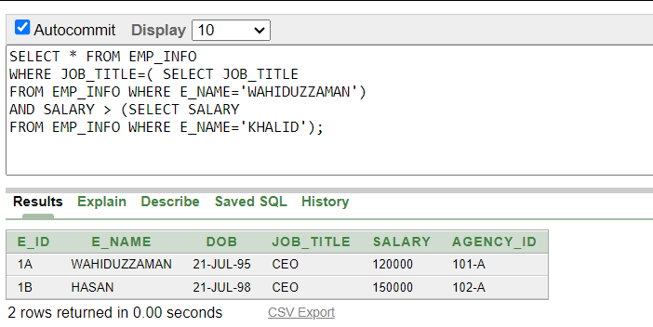

Sub-Query (Multiple Row):

09.Show Payment information more than any of the customer id 10.

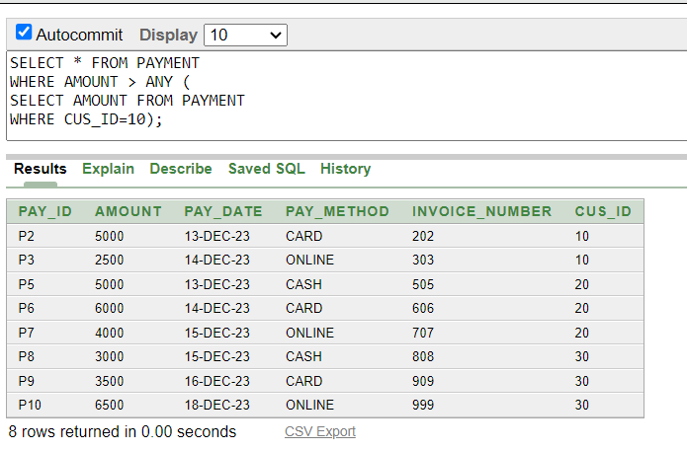

10.Show Payment information more than all the customer id 10.

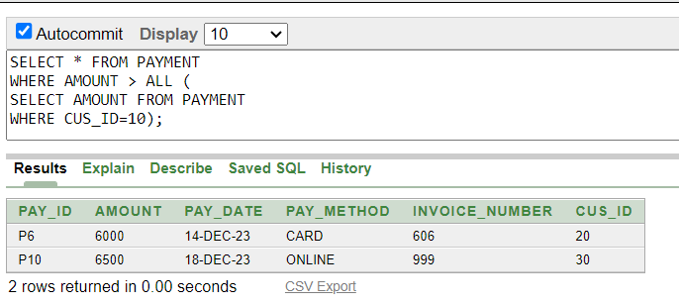

11.Show the list of Payments which are as same as customer id 10.

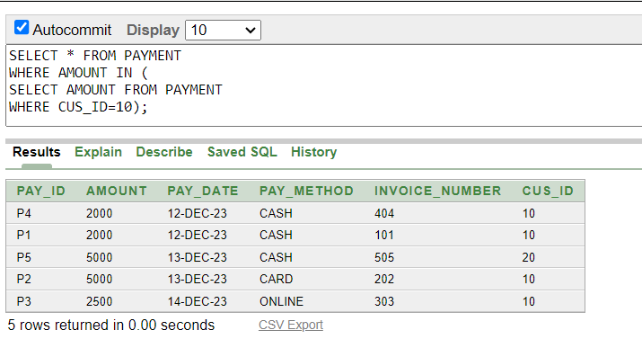

Aggregate Function Query:
12.Show maximum and minimum salary from Emp_Info table using group by clause.

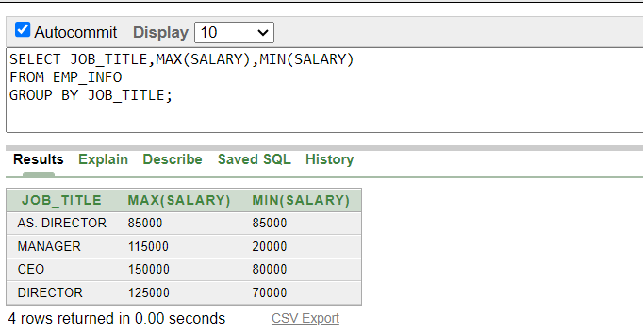

13.Show maximum,minimum,average and sum of the salaries of the managers from Emp_info Table.
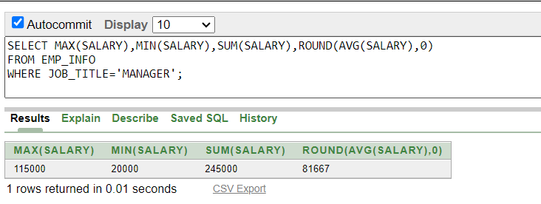
14.Show average amounts of payment which is more than 3000 using group by clause.
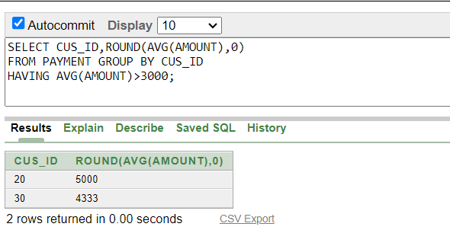15.Show the maximum average salary from Emp_Info Table.
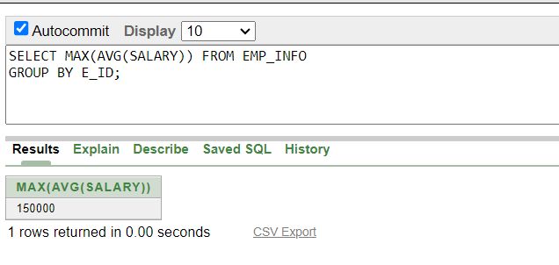
Joining Query:
16.Show all the payments information of all the customers.
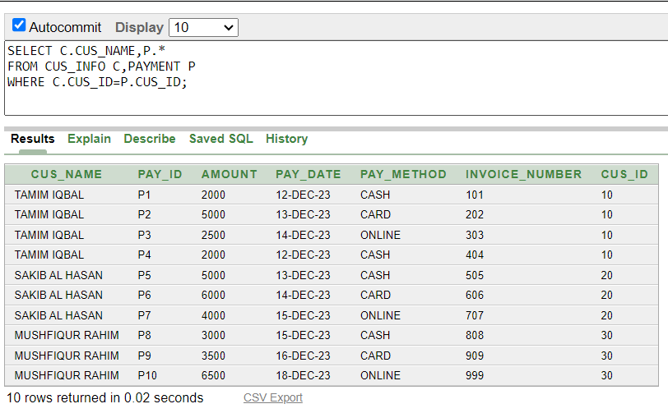

17.Show flights and hotels information together of the customers.
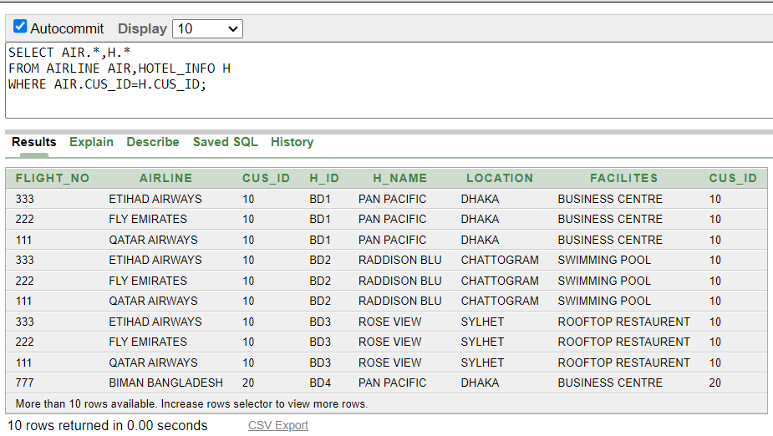
18.Show the agencial information of all the employees.
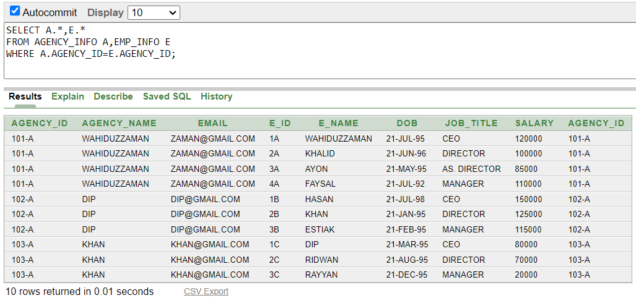

View Query :
19. Create a view called Airways based on flight_no,Airline and customer id where customer id is 10.

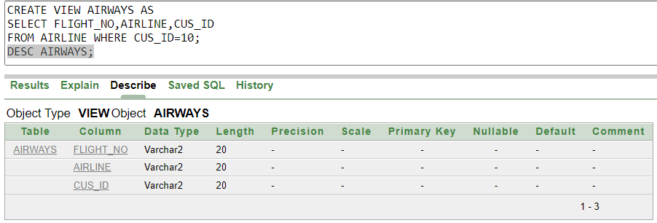

20. Create a view called Housing based on types of room,room no,check in and check out dates.

